**CalculateScore.js:**

import "../Stylesheets/mystyle.css";

const CalculateScore = ({ *Name*, *School*, *total*, *goal* }) => {

  const percentToDecimal = (*decimal*) => {

    return decimal.toFixed(2) + "%";

  };

  const calcScore = (*total*, *goal*) => {

    return percentToDecimal(total / goal);

  };

  return (

    <div className="formastyle">

      <h1>

        <font color="Brown">Student Details:</font>

      </h1>

      <div className="Name">

        <b>

          <span>Name:</span>

        </b>

        <span>{Name}</span>

      </div>

      <div className="School">

        <b>

          <span>School:</span>

        </b>

        <span>{School}</span>

      </div>

      <div className="Total">

        <b>

          <span>Total:</span>

        </b>

        <span>{total}</span>

        <span>Marks</span>

      </div>

      <div className="Score">

        <b>Score:</b>

        <span>{calcScore(total, goal)}</span>

      </div>

    </div>

  );

};

export default CalculateScore;

**mystyle.css:**

.Name{

font-weight: 300;

color: blue;

}

.School{

color: crimson;

}

.Total{

color: darkmagenta;

}

.formatstyle{

text-align: center;

font-size: large;

}

.Score{

color: forestgreen;

}

**App.js**

import './App.css';

import CalculateScore from './Components/CalculateScore';

function App() {

  return (

    <div className="App">

      <CalculateScore Name={"Sayan"} School={"St. Claret School"} total={284} goal={3} />

    </div>

  );

}

export default App;

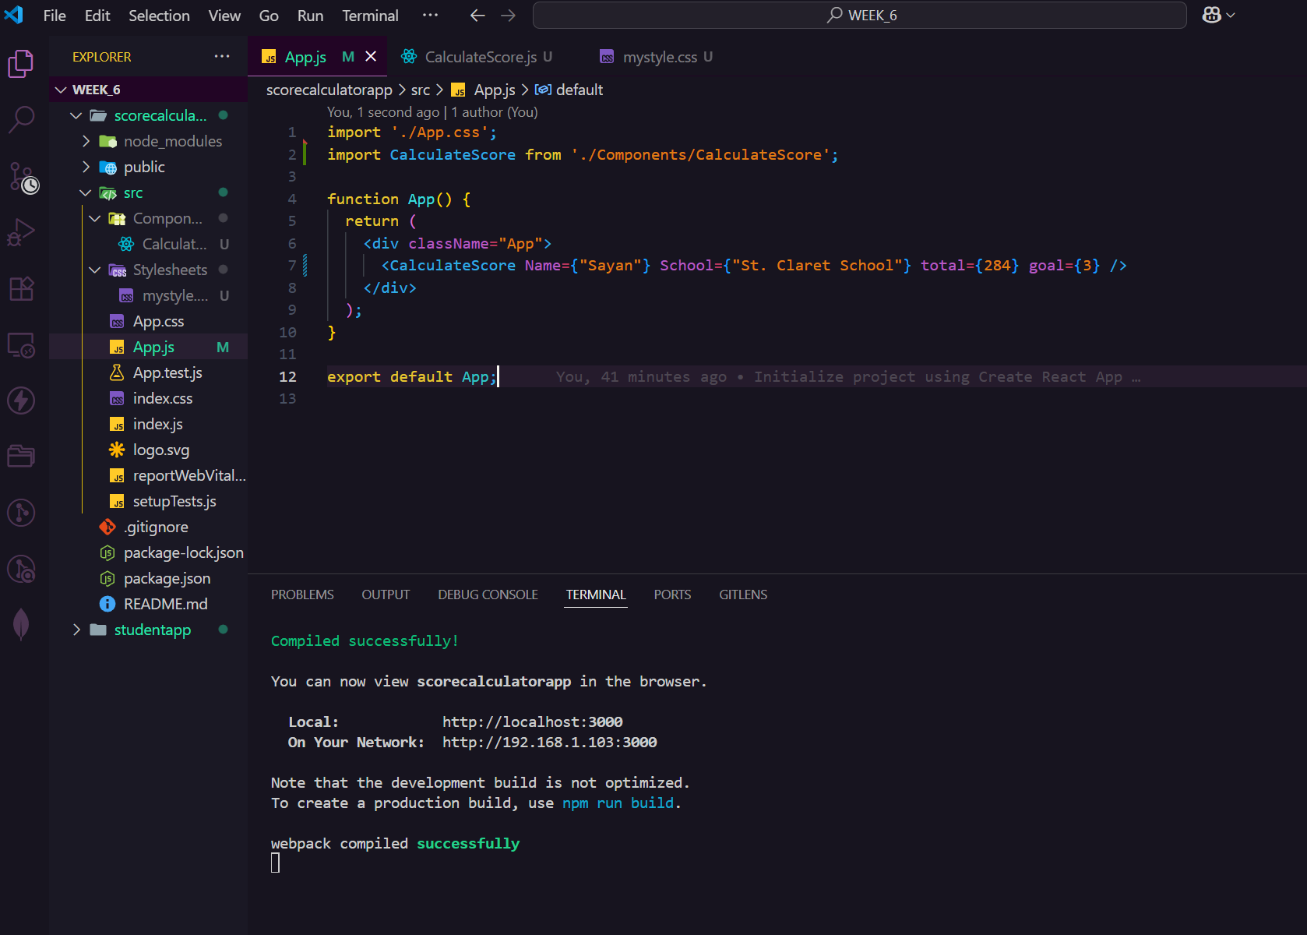

**OUTPUT:**

